ORTHOPAEDIC INSTRUMENTS
Instruments for Spinal Surgery
Bone Hooks
Intended Use
Bone hooks are retraction instruments used in veterinary spinal surgery to retract vertebral structures, intervertebral discs and surrounding soft tissue during laminectomy, discectomy and spinal stabilisation procedures in dogs and cats. They provide controlled tissue displacement to expose the spinal canal and facilitate spinal cord decompression. | 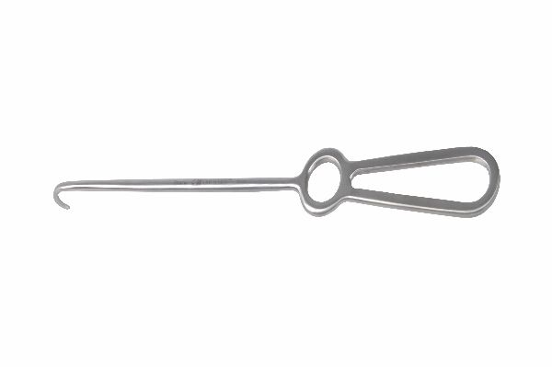
Function
The hook tip curves around bone or soft-tissue edges; manual pull on the handle retracts the tissue away from the operative field. The curved tip engages the lamina edge, transverse process or pedicle without the instrument obscuring the surgeon's view of the spinal canal. Self-retaining versions can be linked to frame retractors to maintain retraction without continuous hand holding.
Advantages
Targeted Lamina and Vertebral Retraction: The curved hook tip engages specific bony landmarks such as the lamina edge and transverse process, enabling precise retraction of the minimal tissue volume required for spinal canal exposure without inadvertently retracting spinal cord or nerve roots.
Minimal Visual Obstruction During Cord Decompression: The slender hook profile and angled handle keep the surgeon's hand and instrument body out of the direct line of sight to the spinal canal, maintaining the unobstructed view needed for safe disc material removal and cord decompression.
FAQ
Q: What size bone hooks are used in small animal spinal surgery?
A: Small (2–4 mm tip width) bone hooks are used in cats and small dogs for cervical and thoracolumbar laminectomy; medium hooks (4–6 mm) are used in medium and large breeds for thoracolumbar and lumbosacral procedures.
Q: Can bone hooks be used in arthroscopic spinal procedures?
A: Standard bone hooks are open-surgery instruments; arthroscopic or minimally invasive spinal procedures use purpose-designed probe hooks sized for the working portal diameter.

ORTHOPAEDIC INSTRUMENTS
Instruments for Spinal Surgery
Bone Scoop (Volkmann) S,M,L
Intended Use
Volkmann bone scoops are sharp-edged curette instruments available in small, medium and large sizes, used in veterinary spinal and orthopaedic surgery to remove disc material, degenerative nucleus pulposus, bone spurs and soft-tissue debris from the spinal canal and intervertebral disc spaces in dogs and cats during decompressive procedures. | 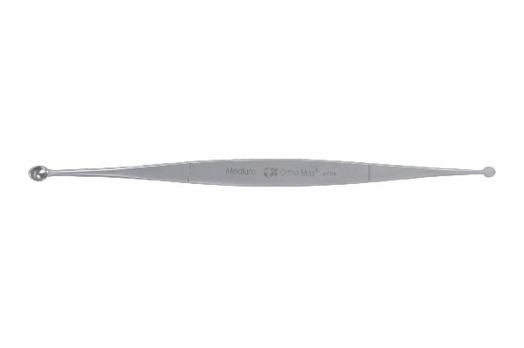
Function
Each scoop has a hollow, spoon-shaped cup with sharp cutting edges. The cup is advanced into the disc space or epidural space and rotated or dragged to scoop out soft and semi-solid material. The sharp edges cut through fibrous annular material and calcified disc fragments. The hollow cup collects the removed material, preventing it from falling back into the surgical field.
Advantages
Size-Matched Canal Access in Small, Medium and Large Patients: The three-size range provides scoop cup dimensions matched to the intervertebral disc space and spinal canal cross-sections of cats and toy breeds (small), medium breeds (medium) and large breeds (large), ensuring effective material removal without excessive canal manipulation.
Sharp Cutting Edges for Calcified Disc Material: Hardened cutting edges on the scoop rim cut through calcified nucleus pulposus and mineralised annular fragments that blunt curettage instruments cannot remove, enabling more complete disc space debridement during thoracolumbar disc surgery.
FAQ
Q: How is the correct Volkmann scoop size selected for a spinal procedure?
A: Scoop size is selected based on preoperative myelography or MRI-measured disc space height and canal diameter; the scoop cup should be slightly smaller than the disc space to allow insertion without forcing the canal walls.
Q: Are Volkmann scoops used in cervical disc surgery as well as thoracolumbar?
A: Yes. Small Volkmann scoops are used in cervical disc fenestration and ventral slot procedures; medium and large sizes are used for thoracolumbar hemilaminectomy and pediculectomy disc removal in large-breed dogs.

ORTHOPAEDIC INSTRUMENTS
Instruments for Spinal Surgery
Bone Scoop with Fibre Handle - Long
Intended Use
The long bone scoop with fibre handle is an extended-reach disc and bone fragment removal instrument used in veterinary spinal surgery to access deep spinal canal structures and distant disc spaces during laminectomy and discectomy procedures in dogs and cats. The long handle reaches disc spaces inaccessible to standard-length scoops. | 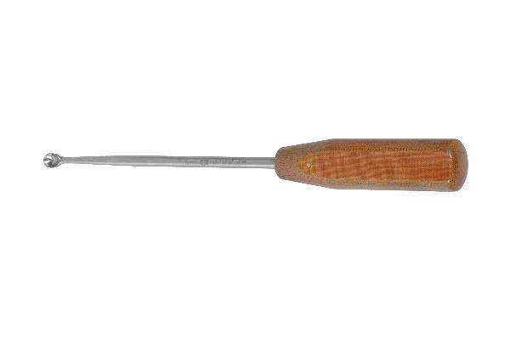
Function
The extended fibre handle reduces hand tremor transmission to the scoop tip compared with solid metal handles, providing enhanced tactile sensitivity during delicate disc material removal adjacent to the spinal cord. The long reach allows the surgeon to maintain an ergonomic hand position outside the wound while the scoop cup works deep within the laminectomy trough or vertebral disc space.
Advantages
Extended Reach for Deep Spinal Canal Access: The long handle provides 15–20 cm additional working depth compared with standard scoops, enabling disc material removal from the contralateral side of the spinal canal without rotating or repositioning the patient or extending the laminectomy window.
Fibre Handle Vibration Dampening: The composite fibre handle absorbs fine hand vibrations that would be transmitted to the scoop tip by rigid metal handles, providing superior tactile feedback for detecting residual disc material and reducing the risk of inadvertent spinal cord contact during deep canal curettage.
FAQ
Q: In which spinal procedures is the long-handled bone scoop most useful?
A: Long-handled scoops are most valuable in thoracolumbar disc herniation cases where the extruded material has migrated cranially or caudally beyond the standard laminectomy window and in deep lumbosacral discectomy in large-breed dogs.
Q: How is the fibre handle sterilised?
A: Fibre-handled instruments should be sterilised by standard gravity or vacuum autoclave cycles; prolonged soaking in chemical sterilants can degrade certain fibre composite materials and should be avoided.

ORTHOPAEDIC INSTRUMENTS
Instruments for Spinal Surgery
Bone Scoops
Intended Use
Bone scoops are standard curette instruments used in veterinary spinal and orthopaedic surgery to remove intervertebral disc material, degenerate nucleus pulposus, cancellous bone and soft-tissue debris from surgical sites in dogs and cats. They are essential instruments in spinal decompression, joint debridement and bone defect preparation procedures. | 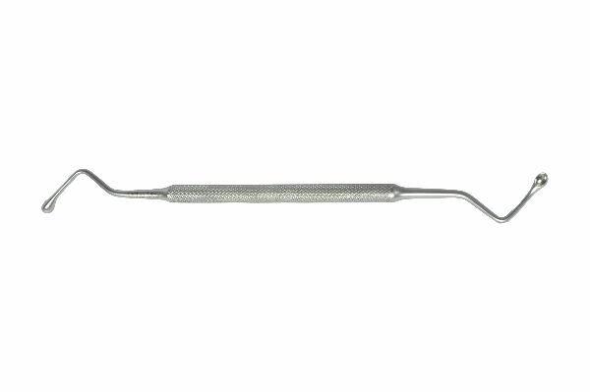
Function
The spoon-shaped cup at the working end has a circular or oval profile with sharp or semi-sharp edges. When pressed against tissue and drawn toward the surgeon, the cup edges scrape and scoop the target material away from the underlying bone or neural tissue surface. Various cup shapes and angles accommodate access to different anatomical sites within the spinal canal and joint spaces.
Advantages
Versatile Multi-Site Disc and Bone Debridement: Standard bone scoops serve across multiple procedures — disc space fenestration, laminectomy cavity clean-up, joint debridement and bone graft site preparation — making them one of the highest-use instruments across veterinary spinal and orthopaedic surgical trays.
Multiple Cup Angles for Varied Access Directions: Straight, angled and curved scoop variants allow material to be removed from surfaces facing the surgeon, perpendicular to the approach, or on the contralateral side of the surgical corridor without repositioning the patient or extending the exposure.
FAQ
Q: What is the difference between bone scoops and Volkmann scoops?
A: Volkmann scoops refer to a specific named design with a defined cup profile, while bone scoops is the general instrument category; in practice the terms are used interchangeably in veterinary surgical instrument catalogues.
Q: How should bone scoops be kept sharp?
A: Scoop edges should be inspected after each use and re-sharpened by the manufacturer or instrument service when the edge no longer cuts cleanly; dull scoops require excessive force and increase the risk of spinal cord contact during disc material removal.

ORTHOPAEDIC INSTRUMENTS
Instruments for Spinal Surgery
Bristow Elevator
Intended Use
The Bristow elevator is a flat-bladed periosteal elevator used in veterinary spinal and orthopaedic surgery to strip periosteum and attached musculature from vertebral laminae, spinous processes and adjacent bones during spinal exposure in dogs and cats. It provides efficient en-bloc periosteal elevation for wide spinal surgical access. | 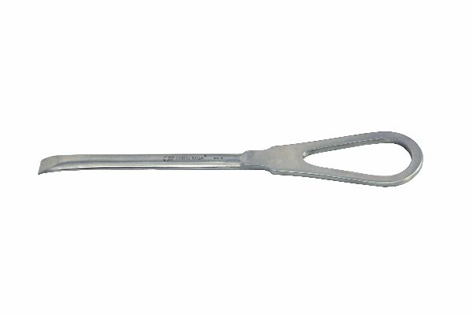
Function
The Bristow elevator has a flat, broad working blade with a slightly curved leading edge. The blade is introduced subperiosteally and advanced with a prying and sweeping motion, stripping muscle and periosteum from the lamina and spinous process surfaces in broad sheets. The wide blade covers more surface area per stroke than a narrow periosteal elevator, reducing the number of strokes needed for complete paraspinal muscle elevation.
Advantages
Wide Blade for Rapid Paraspinal Muscle Elevation: The broad Bristow blade strips larger areas of periosteum per stroke than narrow elevators, reducing the time required for complete paraspinal muscle elevation during dorsal and dorsolateral spinal approaches in large-breed dogs.
Clean Subperiosteal Tissue Plane: The slightly curved leading edge facilitates elevation within the subperiosteal tissue plane, reducing muscle belly bleeding and maintaining a clean anatomical layer that simplifies wound closure and reduces postoperative seroma formation.
FAQ
Q: How does the Bristow elevator differ from a Cobb spinal elevator?
A: The Bristow elevator has a flat, broad blade suited to rapid surface stripping; the Cobb elevator has a curved, wider blade designed for deep paraspinal muscle elevation during extensive spinal approaches such as thoracolumbar laminectomy in large dogs.
Q: Is the Bristow elevator used in cervical spinal surgery?
A: Yes. A narrower-bladed Bristow variant is used for cervical spinal approaches in dogs, where the smaller vertebral surface requires a proportionally narrower blade for effective periosteal elevation without soft-tissue laceration.

ORTHOPAEDIC INSTRUMENTS
Instruments for Spinal Surgery
Capner Gouge with Fibre Handle
Intended Use
The Capner gouge with fibre handle is a specialised cutting instrument used in veterinary spinal surgery to remove laminar bone and perform laminectomy or hemilaminectomy during spinal cord decompression in dogs and cats. Its curved cutting edge removes bone in controlled increments adjacent to the spinal cord. | 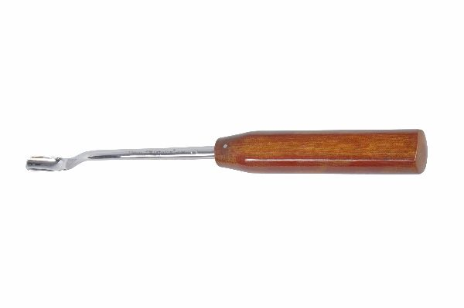
Function
The gouge has a curved, U-shaped or V-shaped cutting blade that is advanced through the laminar bone by mallet taps on the handle. The fibre handle absorbs mallet impact vibrations, reducing transmission to the surgeon's grip and improving controlled stroke delivery. The curved blade profile scoops bone away from the cord surface rather than driving directly toward it, enhancing safety during bone removal adjacent to neural tissue.
Advantages
Controlled Laminar Bone Removal Adjacent to Cord: The curved cutting edge removes bone in a scooping arc away from the spinal cord surface, providing the surgeon with greater control over removal direction compared with flat chisels that must be oriented precisely parallel to the cord to avoid contact.
Fibre Handle Impact Absorption: The composite fibre handle dampens the mallet percussion vibrations that rigid metal handles transmit to the surgeon's grip, reducing hand fatigue during extended laminectomy procedures and improving surgical precision during final thin-shell bone removal.
FAQ
Q: What size Capner gouge is used for thoracolumbar laminectomy in large dogs?
A: A 6–10 mm blade width Capner gouge is typically used for thoracolumbar laminectomy in medium to large-breed dogs; smaller 3–5 mm blades are used in cats and toy breeds and for cervical laminectomy.
Q: Can the Capner gouge be used without a mallet?
A: Light bone removal in thin laminae can be achieved by hand pressure alone; mallet use is recommended for initial entry and thick cortical bone removal to provide adequate force without over-applying manual pressure that could cause uncontrolled gouge advancement.

ORTHOPAEDIC INSTRUMENTS
Instruments for Spinal Surgery
Cobb's Spinal Elevator
Intended Use
Cobb's spinal elevator is a heavy-duty curved periosteal elevator used in veterinary spinal surgery to elevate the deep paraspinal musculature from the vertebral laminae and spinous processes during extensive dorsal and dorsolateral spinal approaches in dogs and cats. It is the primary instrument for wide paraspinal exposure in laminectomy procedures. | [Missing: Cobb's Spinal Elevator.jpg]
Function
The Cobb elevator has a wide, curved working blade set at an angle to the handle, matching the curvature of the laminar surface. The blade is introduced under the paraspinal muscle group and swept laterally along the lamina, elevating the muscular attachment in a continuous sheet. The wide blade covers the full laminar width per stroke, enabling rapid bilateral muscle elevation from the spinous processes to the facet joints.
Advantages
Wide Curved Blade Matches Laminar Contour: The blade curvature is designed to conform to the convex dorsal laminar surface, maintaining uniform contact across the full blade width during elevation and preventing tissue tearing from point-loading that occurs with flat blades on curved surfaces.
Efficient Bilateral Paraspinal Muscle Elevation: The broad Cobb blade can elevate the full dorsal laminar muscle attachment bilaterally in fewer strokes than narrower instruments, substantially reducing the surgical exposure time for multi-level laminectomy in the thoracolumbar spine.
FAQ
Q: What is the standard approach for using the Cobb elevator in spinal surgery?
A: After midline skin and subcutaneous dissection, the Cobb elevator is used to strip paraspinal muscles subperiosteally from the spinous processes and laminae bilaterally, working from medial to lateral to expose the laminar-facet junction.
Q: Are Cobb elevators used in minimally invasive spinal surgery?
A: Standard Cobb elevators are open-surgery instruments. Minimally invasive spinal approaches use tubular retractor systems with dedicated narrow channel elevators rather than the wide Cobb blade.

ORTHOPAEDIC INSTRUMENTS
Instruments for Spinal Surgery
Disc Punch
Intended Use
The disc punch is a precision cutting instrument used in veterinary spinal surgery to remove intervertebral disc material, annulus fibrosus and degenerate nucleus pulposus from the disc space during discectomy, fenestration and ventral slot procedures in dogs and cats with intervertebral disc disease. | 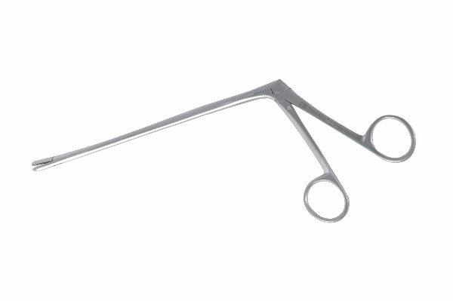
Function
The punch consists of a hollow shaft with a small cup-shaped cutting head at the distal end and a spring-loaded plunger mechanism at the proximal end. Squeezing the handle advances the cutting cup against a fixed anvil, shearing a small piece of disc material that is captured within the hollow shaft. The punch is repositioned and fired repeatedly to progressively remove disc material in controlled small increments.
Advantages
Controlled Incremental Disc Material Removal: The cup-and-anvil shearing mechanism removes disc material in precisely sized bites rather than the variable, uncontrolled amounts removed by curettage scoops, enabling careful disc debridement adjacent to the spinal cord and nerve roots.
Angled Head Designs for Lateral Disc Access: Angled disc punch variants allow removal of laterally extruded disc material in the paramedian epidural space that straight instruments cannot reach without rotating the patient or extending the hemilaminectomy window medially.
FAQ
Q: What is the difference between a disc punch and an intervertebral disc rongeur?
A: A disc punch shears material with a cup-and-anvil mechanism producing small defined bites; a rongeur bites tissue with opposing cupped jaws. Disc punches provide finer, more controlled disc material removal adjacent to neural tissue.
Q: Is the disc punch also used in cervical disc surgery?
A: Yes. Small angled disc punches are used in canine cervical ventral slot procedures for nucleus pulposus removal; they are the preferred instrument for ventral slot debridement where the small slot dimensions preclude use of larger curettage instruments.

ORTHOPAEDIC INSTRUMENTS
Instruments for Spinal Surgery
Doyen's Rib Shear
Intended Use
Doyen's rib shear is a heavy-duty cutting instrument used in veterinary thoracic and spinal surgery to transect ribs during intercostal and costotransversectomy approaches for thoracic spinal cord decompression and thoracic mass removal in dogs and cats. It cuts rib bone cleanly in a single action. | [Missing: Doyen's Rib Shear.jpg]
Function
The shear has two curved blades arranged like scissors; one blade has a curved, protective guard that slides over the rib posteriorly while the cutting blade delivers the transecting force. Squeezing the handles drives the upper cutting blade against the protected lower blade, shearing through the rib cortex and medullary bone cleanly. The guard prevents the lower blade from cutting into the intercostal vessels and pleura during rib transection.
Advantages
Single-Action Clean Rib Transection: The shear mechanism cuts through the full rib cross-section in one squeeze, producing a smooth cut surface without the splintering and fragmentation caused by rib-cutting with bone cutters or oscillating saws, reducing the risk of sharp bone fragment injury to the pleura.
Protected Lower Blade Prevents Neurovascular Injury: The guard on the lower blade protects the neurovascular bundle and pleura from the cutting blade during rib transection, substantially reducing the risk of haemothorax and intercostal nerve damage during costotransversectomy spinal approaches.
FAQ
Q: In which veterinary spinal procedures are Doyen rib shears used?
A: Doyen rib shears are used in thoracic costotransversectomy and lateral thoracotomy approaches for thoracic disc herniation decompression and spinal stabilisation in dogs where dorsal approaches provide insufficient access.
Q: Can Doyen rib shears be used in cats?
A: Yes. A smaller-jawed Doyen variant or bone-cutting forceps may be used in cats where the smaller rib diameter makes the standard canine shear unnecessarily large, risking crush fracture rather than clean transection.

ORTHOPAEDIC INSTRUMENTS
Instruments for Spinal Surgery
Farabeuf Rugine
Intended Use
The Farabeuf rugine is a double-ended periosteal elevator used in veterinary spinal and orthopaedic surgery to strip periosteum from bone surfaces during spinal approaches, fracture exposure and soft-tissue debridement procedures in dogs and cats. Its two different blade ends accommodate elevation of different anatomical surfaces in a single instrument. | 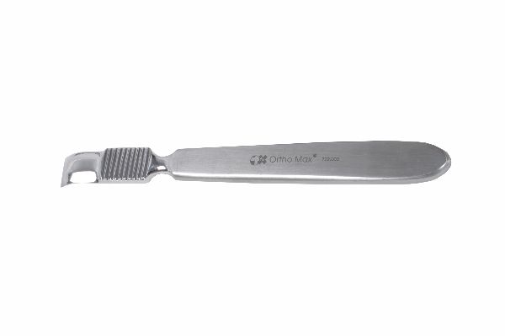
Function
Each end of the Farabeuf rugine has a working blade of different width or angulation. The flat, leading blade edge is introduced subperiosteally and advanced by firm hand pressure combined with a prying and sliding motion, lifting the periosteum from the bone cortex. The double-ended design allows the surgeon to select the most appropriate blade width for the surface being elevated without exchanging instruments.
Advantages
Double-Ended Design Provides Two Blade Sizes: The dual-end configuration gives the surgeon immediate access to two blade widths or angles in a single instrument, reducing the number of instrument exchanges and the instrument count required for complete periosteal elevation during spinal surgical exposure.
Smooth Subperiosteal Elevation Without Cortical Damage: The rounded leading blade edge slides cleanly in the subperiosteal plane without scoring the cortical surface, preserving cortical integrity that is critical for screw purchase and bone healing in subsequent spinal stabilisation procedures.
FAQ
Q: How does the Farabeuf rugine differ from the Cobb spinal elevator?
A: The Farabeuf rugine is a lighter, double-ended instrument for precise periosteal stripping on smaller surface areas; the Cobb elevator is heavier and wider, designed for rapid bulk periosteal elevation from the broad laminar surfaces during extensive spinal laminectomy approaches.
Q: Is the Farabeuf rugine used in dental surgery as well as orthopaedics?
A: Yes. Farabeuf rugines are used in veterinary dental surgery for periosteal elevation during oral surgical procedures such as tooth extraction and mandibular fracture repair, where their fine blade profile suits the small working field.

ORTHOPAEDIC INSTRUMENTS
Instruments for Spinal Surgery
Gillies Skin Hook
Intended Use
Gillies skin hooks are fine single or double-hook retractors used in veterinary orthopaedic and spinal surgery to atraumatically retract skin edges, subcutaneous tissue and delicate structures during wound incision, dissection and closure in dogs and cats. Their fine hooks minimise skin edge trauma during retraction. | 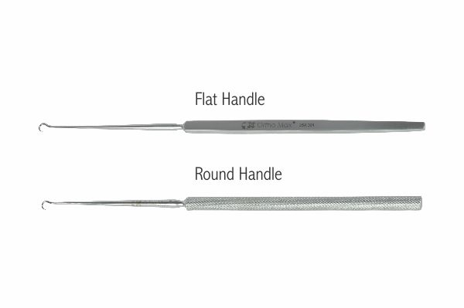
Function
The instrument has one or two fine, sharp hooks at the distal end of a slender handle. The hook tip is introduced through the dermis at the wound edge, and gentle lateral traction on the handle retracts the skin without the crushing force associated with forceps. The sharp hook engages the dermis at a single small-contact point, distributing retraction stress over minimal tissue.
Advantages
Atraumatic Single-Point Skin Retraction: The fine hook tip engages the dermis at a minimal-area contact point, exerting retraction force without the broad crushing effect of toothed forceps on skin edges — critical for preserving incision edge viability in long spinal and orthopaedic incisions.
Unobstructed Wound Visibility During Retraction: The slender hook profile and lightweight handle introduce minimal instrument mass into the surgical field, maintaining the surgeon's view of the wound edges and underlying tissue layers during skin retraction.
FAQ
Q: What is the difference between a single and double Gillies hook?
A: A single hook provides point retraction for precise skin edge control; double hooks engage a broader skin area and are more efficient for retracting longer wound segments, such as extended spinal or orthopaedic incisions.
Q: Can Gillies skin hooks be used for deep tissue retraction?
A: Gillies hooks are designed primarily for skin and subcutaneous tissue retraction; for deeper tissue retraction in orthopaedic surgery, Hohmann elevators and self-retaining retractors are more appropriate.

ORTHOPAEDIC INSTRUMENTS
Instruments for Spinal Surgery
Howarth Elevator
Intended Use
The Howarth elevator is a lightweight double-ended periosteal elevator used in veterinary spinal and orthopaedic surgery for delicate periosteal and soft-tissue elevation around vertebrae, small bones and joint structures in dogs and cats. Its fine blade profiles are suited to precision work in narrow anatomical spaces. | 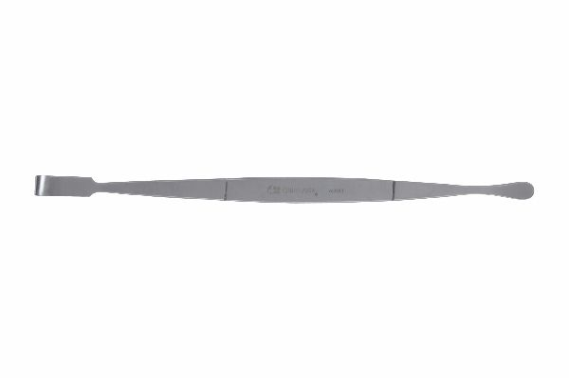
Function
Each end of the Howarth elevator has a differently sized flat or slightly curved blade. The blade is introduced subperiosteally with gentle pressure and advanced in a prying motion along the bone surface. The lightweight construction enables fine tactile feedback, allowing the surgeon to feel the resistance change that indicates entry into the subperiosteal plane versus cortical bone contact during elevation.
Advantages
Fine Tactile Feedback for Delicate Elevation: The lightweight instrument construction transmits subtle tissue resistance changes directly to the surgeon's fingertips, enabling accurate identification of the subperiosteal plane and preventing inadvertent elevation in the wrong tissue layer.
Double-Ended Design for Narrow Anatomical Access: The two blade ends with different widths allow the surgeon to select the appropriate blade for the exact anatomical surface being elevated — the narrower end for spinal facet joints and the wider end for laminar surfaces — without instrument exchange.
FAQ
Q: What is the Howarth elevator used for specifically in spinal surgery?
A: The Howarth elevator is used for periosteal elevation from vertebral spinous processes, laminae and facet joint capsules during dorsal and dorsolateral spinal approaches, and for soft-tissue elevation around the cauda equina in lumbosacral surgery.
Q: How does the Howarth elevator compare to the Molt elevator in veterinary use?
A: The Howarth elevator has a flatter, more delicate blade suited for spinal periosteal elevation; the Molt elevator has a sturdier, more curved blade traditionally used in dental surgery and oral mucoperiosteal elevation.

ORTHOPAEDIC INSTRUMENTS
Instruments for Spinal Surgery
Kerrison Laminectomy Punch
Intended Use
The Kerrison laminectomy punch is a precision bone-removing instrument used in veterinary spinal surgery to perform laminectomy and foraminotomy during spinal cord and nerve root decompression in dogs and cats with intervertebral disc disease, spinal stenosis and spinal tumours. It removes bone in controlled small increments adjacent to neural tissue. | 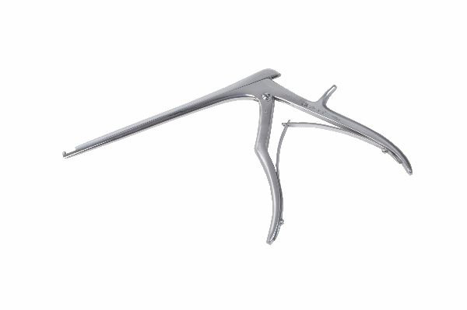
Function
The Kerrison punch consists of a footplate that slides epidurally under the lamina to protect the dura, and a cutting head that shears a small bite of bone when the handle is squeezed. The sheared bone fragment is captured within the instrument shaft. By repositioning and firing the punch repeatedly, the surgeon progressively removes the laminar bone to create the laminectomy window while the footplate continuously protects the spinal cord from accidental contact.
Advantages
Dural Protection During Bone Removal: The footplate slides epidurally between the bone and dura mater, creating a constant physical barrier that protects the spinal cord from the cutting head during each bite, reducing the risk of inadvertent dural laceration during laminectomy.
Controlled Small-Increment Bone Removal: Each punch bite removes a small, precisely sized piece of laminar bone, enabling highly controlled progression of the laminectomy window that minimises the risk of a single large bone fragment falling onto the spinal cord.
FAQ
Q: What Kerrison punch sizes are used in veterinary spinal surgery?
A: Kerrison punches of 2 mm, 3 mm and 4 mm bite widths are most commonly used in small animal spinal surgery; the size is selected based on patient size and the width of the laminectomy window required for adequate decompression.
Q: Is the Kerrison punch suitable for removing mineralised disc material?
A: The Kerrison punch is optimised for laminar bone removal; highly mineralised disc fragments within the spinal canal may be removed using the punch footplate to protect the cord, but dedicated disc punches and scoops are preferred for disc material removal.

ORTHOPAEDIC INSTRUMENTS
Instruments for Spinal Surgery
Lamina Bone Spreader with Speed Lock
Intended Use
The lamina bone spreader with speed lock is a self-retaining retractor used in veterinary spinal surgery to separate and maintain the spacing between vertebral laminae during laminectomy and interspinous stabilisation procedures in dogs and cats. The speed-lock mechanism secures the desired distraction distance without manual holding. | 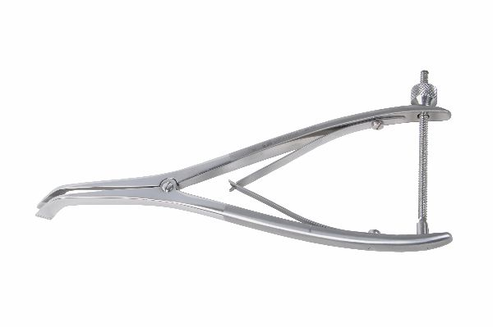
Function
The spreader has two opposing blades that are introduced into the interspinous or interlaminar space. Squeezing the handles separates the blades, distracting the laminae and spinous processes. The speed-lock ratchet mechanism engages to hold the blades at the selected separation distance without continuous hand pressure. The lock releases instantly by depressing the quick-release button, allowing rapid repositioning.
Advantages
Hands-Free Laminar Distraction: The speed-lock ratchet maintains laminar distraction without manual holding, freeing both the surgeon's hands for spinal cord decompression, disc material removal and implant placement during the operative phase.
Rapid Position Adjustment with Speed Lock: The speed-lock mechanism allows rapid laminar distraction increments by sequential ratchet advancement, and instant full release by pressing the quick-release button, enabling efficient surgical field adjustment during laminectomy without instrument removal.
FAQ
Q: What is the maximum laminar distraction provided by this spreader?
A: Veterinary lamina bone spreaders typically provide 0–40 mm of distraction, sufficient for interspinous distraction in dogs ranging from small to large breeds during thoracolumbar and cervical laminectomy procedures.
Q: Can the lamina spreader be used for other spinal procedures?
A: Yes. The spreader is also used to distract facet joints during facetectomy, to open the interspinous space for spinal staple or wire placement during dorsal stabilisation, and to access the ventral spinal canal floor from a dorsal approach.

ORTHOPAEDIC INSTRUMENTS
Instruments for Spinal Surgery
Laminectomy Retractor with Follow-up Blades
Intended Use
The laminectomy retractor with follow-up blades is a self-retaining wound retractor used in veterinary spinal surgery to maintain wide surgical exposure of the dorsal spine during laminectomy and spinal cord decompression in dogs and cats. Follow-up blades are added to deepen retraction as the surgical exposure progresses. | 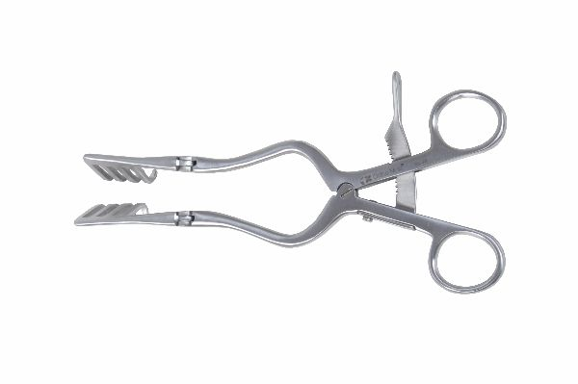
Function
The retractor frame holds two opposing primary blades that retract the paraspinal muscles laterally. As muscle elevation progresses deeper, follow-up blade extensions are attached to the primary blades to maintain tissue retraction at the new, deeper level without repositioning the retractor frame. The self-retaining mechanism maintains constant retraction force without manual holding throughout the procedure.
Advantages
Progressive Depth Retraction with Follow-Up Blades: The modular follow-up blade system deepens retraction in parallel with surgical dissection progress, maintaining optimal exposure at each operative depth without the blade-to-wound mismatch that occurs when fixed-depth blades are used for progressively deeper spinal approaches.
Hands-Free Self-Retaining Operation: The retractor frame maintains paraspinal muscle retraction without manual holding throughout the laminectomy, freeing the surgeon and assistant to perform bilateral paraspinal muscle elevation, bone removal and cord decompression without retraction interruptions.
FAQ
Q: What spacing of retractor blades is appropriate for canine thoracolumbar laminectomy?
A: Initial blade placement at 20–30 mm separation is typical for thoracolumbar laminectomy in medium-breed dogs; follow-up blades add depth as the laminectomy progresses, with final exposure width determined by the number of vertebral levels being addressed.
Q: Can follow-up blades be added from both sides simultaneously?
A: Yes. Bilateral follow-up blade addition deepens retraction symmetrically on both sides simultaneously, maintaining centred exposure of the spinous processes and laminae throughout multi-level thoracolumbar laminectomy procedures.

ORTHOPAEDIC INSTRUMENTS
Instruments for Spinal Surgery
McDonald Dissector
Intended Use
The McDonald dissector is a blunt-tipped dissecting and probing instrument used in veterinary spinal surgery to develop tissue planes around the spinal cord and nerve roots, identify disc herniations and probe the spinal canal during decompression procedures in dogs and cats. Its smooth tip prevents inadvertent neural tissue laceration. | 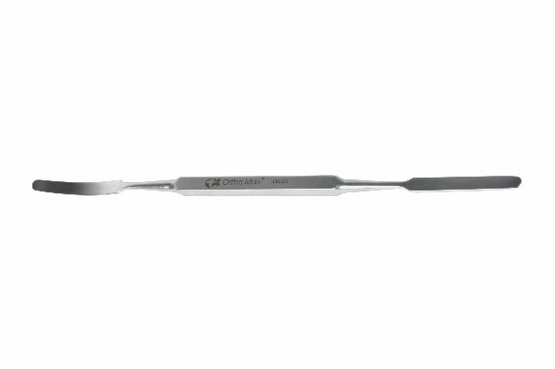
Function
The instrument has a long, narrow shaft with a blunt, slightly angled or spatula tip at the distal end. The tip is introduced into the epidural space or disc space and used to probe for disc material, develop the tissue plane between dura and herniated disc, and mobilise free disc fragments for removal with scoops or rongeurs. The smooth tip slides along neural tissue surfaces without cutting.
Advantages
Blunt Tip Safe for Epidural and Intradural Use: The smooth, rounded tip can be used adjacent to the spinal cord and nerve roots without the laceration risk associated with sharp-tipped instruments, enabling safe tissue plane development and disc fragment mobilisation in the confined epidural space.
Thin Profile for Narrow Spinal Canal Access: The slender shaft and narrow tip profile allow introduction into the limited epidural space of small canine and feline spines without requiring enlargement of the decompression window beyond the minimum needed for effective cord decompression.
FAQ
Q: What is the McDonald dissector used for in disc surgery?
A: The McDonald dissector is used to probe the lateral recesses and ventral epidural space for residual disc material after hemilaminectomy, to develop the plane between the dura and herniated disc and to confirm spinal cord decompression after bone and disc removal.
Q: Is the McDonald dissector the same as a nerve hook?
A: The McDonald dissector has a blunt spatula or probe tip for general epidural plane development; nerve hooks have a fine curved tip specifically for isolating and retracting individual nerve root branches. Both are used in spinal cord decompression procedures.

ORTHOPAEDIC INSTRUMENTS
Instruments for Spinal Surgery
Molt Elevator
Intended Use
The Molt elevator is a sturdy double-ended periosteal elevator used in veterinary oral and spinal surgery for periosteal and mucoperiosteal elevation during dental extraction, mandibular fracture repair and vertebral periosteal stripping in dogs and cats. Its two different blade ends cover a range of elevation tasks in a single instrument. | 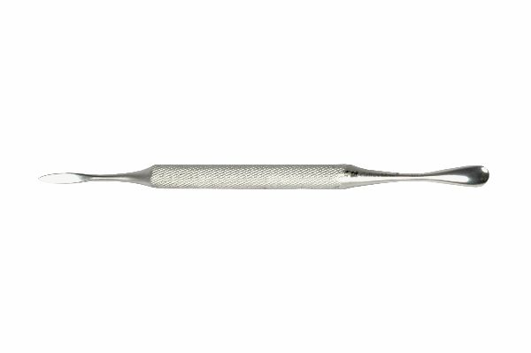
Function
The Molt elevator features a pointed blade on one end for initial periosteal incision penetration and a flat, wider blade on the other for broad periosteal elevation by prying and sweeping. Both ends are hardened stainless steel for durability under the firm pressure required for periosteal elevation. The sturdy handle provides the leverage needed for elevating tightly adherent periosteum from cortical bone surfaces.
Advantages
Dual-Ended Design for Initial Penetration and Broad Elevation: The pointed end penetrates initial periosteal incisions and tight interproximal spaces; the flat end then performs broad-area elevation — the two functional profiles in one instrument covering the full periosteal elevation workflow without instrument exchange.
Robust Construction for Firmly Adherent Periosteum: The heavy-gauge stainless steel construction withstands the firm prying force required to elevate tightly adherent periosteum from cortical bone in the vertebral column, mandible and long bones without handle flex or blade deformation.
FAQ
Q: What is the primary veterinary use of the Molt elevator?
A: The Molt elevator is used primarily for oral mucoperiosteal flap elevation during dental extraction and oral surgery, and secondarily as a periosteal elevator during mandibular fracture repair and bone plating in the face and skull.
Q: How does the Molt elevator differ from the Hohmann elevator?
A: The Molt elevator is a periosteal elevator used for surface tissue stripping; the Hohmann elevator is a retractor with a curved spatula tip used to lever soft tissue away from bone and maintain retraction during fracture fixation and joint surgery.

ORTHOPAEDIC INSTRUMENTS
Instruments for Spinal Surgery
Periosteal Elevator Big
Intended Use
The large periosteal elevator is a heavy-duty instrument used in veterinary orthopaedic and spinal surgery to elevate periosteum and attached musculature from the cortical surfaces of large bones and vertebrae in medium to giant-breed dogs and equines. Its wide blade enables rapid, broad-area periosteal stripping during major surgical approaches. | 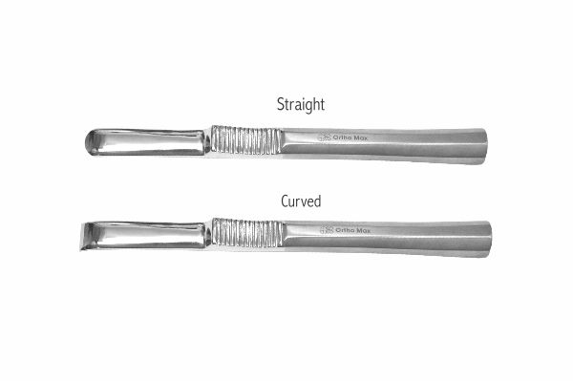
Function
The wide, flat blade is driven subperiosteally by firm manual pressure and a prying lever motion. The large blade surface contact area reduces the number of instrument strokes required to strip periosteum from broad cortical surfaces such as the femoral diaphysis, tibial plateau and thoracolumbar laminae. The heavy handle provides the leverage needed for stripping tightly adherent periosteum in large patients.
Advantages
Wide Blade for Rapid Large-Surface Periosteal Stripping: The broad blade covers significantly more cortical surface per stroke than standard elevators, reducing the time required for complete periosteal elevation in large-breed dogs and equines where the bone surfaces are substantially larger.
Heavy-Duty Construction for Dense Cortical Adherence: The robust blade and handle construction withstand the high prying forces required to strip the tightly adherent periosteum and overlying musculature from the dense cortical bone of large-breed dog femora and equine long bones without blade deflection or handle breakage.
FAQ
Q: When is a large periosteal elevator used instead of a standard size?
A: The large elevator is used in medium, large and giant-breed dogs for broad-area periosteal stripping during fracture plating, laminectomy, spinal stabilisation and bone grafting where the bone surface area being elevated exceeds what a standard elevator can address efficiently.
Q: What is the difference between a large periosteal elevator and a Cobb spinal elevator?
A: Both strip periosteum from large bone surfaces; the Cobb elevator has a specific curved blade profile optimised for the contoured laminar surface, while the large periosteal elevator has a flat blade suited for the generally flat cortical surfaces of long bones.

ORTHOPAEDIC INSTRUMENTS
Instruments for Spinal Surgery
Periosteal Elevator with Fibre Handle
Intended Use
The periosteal elevator with fibre handle is a tactile-enhanced periosteal stripping instrument used in veterinary spinal and orthopaedic surgery for periosteal elevation from vertebrae and long bones in dogs and cats. The composite fibre handle improves tactile feedback and reduces hand fatigue during extended elevation procedures. | 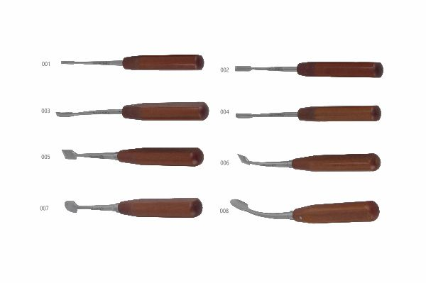
Function
The metal working blade performs subperiosteal elevation by the standard prying-and-sweeping motion. The fibre handle absorbs high-frequency vibrations generated by bone contact during elevation, transmitting only low-frequency tissue resistance feedback to the surgeon's hand. This vibration filtering improves the surgeon's ability to sense periosteal plane entry and bone surface contour during elevation.
Advantages
Enhanced Tactile Feedback Through Vibration Filtering: The fibre handle filters high-frequency vibrations from bone contact while preserving the low-frequency tissue resistance feedback that informs the surgeon about subperiosteal plane entry, improving elevation precision compared with fully rigid metal handles.
Reduced Hand Fatigue During Extended Procedures: Vibration dampening by the fibre handle reduces cumulative hand and forearm fatigue during prolonged periosteal elevation in multi-level spinal procedures, maintaining surgical precision throughout extended operative periods.
FAQ
Q: Does the fibre handle affect the stiffness or blade performance of the elevator?
A: No. The fibre handle affects only handle vibration characteristics and grip comfort; the working blade has identical geometry and stiffness to the equivalent metal-handled version and performs the same subperiosteal elevation function.
Q: Are fibre-handled instruments more fragile than metal-handled equivalents?
A: Modern surgical fibre composites used in instrument handles are highly durable and withstand autoclave sterilisation; however, dropping fibre-handled instruments may cause handle cracking not seen in solid metal-handled instruments.

ORTHOPAEDIC INSTRUMENTS
Instruments for Spinal Surgery
Periosteal Elevator
Intended Use
The standard periosteal elevator is a foundational veterinary orthopaedic and spinal surgical instrument used to lift and separate periosteum from bone cortex during surgical approach, fracture fixation, plate application and spinal decompression procedures in dogs and cats. It provides clean subperiosteal tissue plane development at all operative sites. | 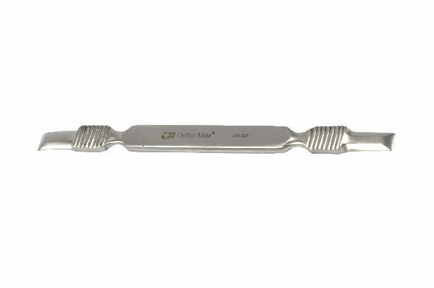
Function
The instrument has a flat or slightly curved working blade with a sharp or semi-sharp leading edge. The edge is introduced into the periosteum at the incision edge and advanced subperiosteally by a prying and sliding motion, separating the periosteal sleeve from the cortex. The handle design transmits adequate force for elevation while providing sufficient grip stability to control the direction and depth of elevation.
Advantages
Fundamental Subperiosteal Plane Development: The standard periosteal elevator defines the correct subperiosteal tissue plane that preserves cortical vascularity and periosteal osteogenic potential — critical for bone healing after fracture fixation and spinal stabilisation procedures.
Universal Application Across Orthopaedic Procedures: The general-purpose design works across the full range of veterinary orthopaedic and spinal sites — long bones, vertebrae, pelvis, skull and mandible — making it the single highest-use elevator instrument across all procedure types.
FAQ
Q: What is the difference between sharp and semi-sharp periosteal elevators?
A: Sharp-edged elevators cut through the periosteum cleanly for initial elevation; semi-sharp elevators are used once the plane is established, providing broader contact with less risk of inadvertent cortical scoring during sweeping elevation strokes.
Q: How should a periosteal elevator be maintained?
A: The blade edge should be inspected for nicks and dullness after each use; a dull elevator requires excessive force and causes tearing rather than clean elevation. The blade should be periodically re-sharpened to maintain optimal cutting performance.

ORTHOPAEDIC INSTRUMENTS
Instruments for Spinal Surgery
Rib Cutter
Intended Use
The rib cutter is a heavy-duty bone-cutting instrument used in veterinary thoracic and spinal surgery to transect ribs during thoracotomy and costotransversectomy approaches for thoracic spinal cord decompression and thoracic mass resection in dogs and cats. It cuts rib bone cleanly and efficiently. | 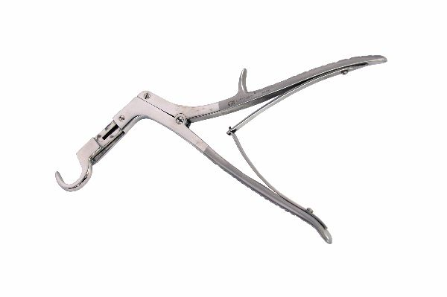
Function
The instrument has two opposing curved cutting jaws that close around the rib. Squeezing the handles drives the cutting edges through the rib cortex and medullary cavity, transecting the rib in a single action. The curved jaw profile accommodates the round rib cross-section, applying uniform cutting force around the entire rib diameter to produce a clean, controlled cut without rib splintering.
Advantages
Clean Single-Action Rib Transection: The opposing jaw mechanism transects the full rib diameter in one squeeze, producing a smooth bone edge without the splintering and irregular cut surfaces caused by saw blades — smooth rib ends reduce pleural and lung tissue injury during thoracic approaches.
Curved Jaws Match Rib Cross-Section: The curved jaw profile conforms to the cylindrical rib anatomy, distributing cutting force uniformly around the rib circumference and preventing the jaw from sliding off the curved rib surface that occurs with straight-bladed cutters.
FAQ
Q: What is the difference between rib cutters and Doyen's rib shears?
A: Rib cutters have opposing closing jaws that cut around the rib circumference; Doyen's shears have a protective footplate that guides under the rib to protect underlying structures. Both achieve rib transection but differ in their tissue protection mechanism.
Q: Can rib cutters be used for other bones in veterinary surgery?
A: Rib cutters are occasionally used for cutting costal cartilage, clavicles (where present) and small bones in exotic animal surgery, though their large jaw profile makes them unsuitable for the small bones of rats, rabbits and other small companion animals.

ORTHOPAEDIC INSTRUMENTS
Instruments for Spinal Surgery
Rib Raspatory - Right & Left in Pair
Intended Use
Rib raspatorys (right and left pair) are periosteal elevator instruments used in veterinary thoracic and spinal surgery to strip intercostal muscles and periosteum from the superior and inferior rib margins during thoracotomy and costotransversectomy approaches for spinal cord decompression and thoracic mass resection in dogs and cats. | 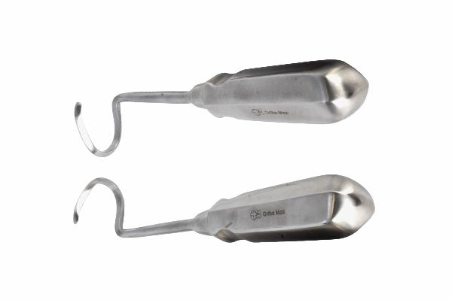
Function
The right and left raspatorys have mirror-image blade curves, one designed to elevate from the superior rib margin and the other from the inferior margin. The curved blade is introduced around the rib surface and drawn along it, stripping the intercostal musculature and periosteum from the bone circumferentially. Using both instruments sequentially provides complete circumferential rib periosteal elevation for clean rib bed preparation.
Advantages
Mirror-Image Pair for Complete Circumferential Rib Elevation: Using right and left raspatorys sequentially provides complementary elevation from both the superior and inferior rib margins, enabling complete circumferential periosteal stripping of the rib segment being resected in a single systematic workflow.
Curved Blade Conforms to Rib Anatomy: Each raspatory blade is curved to match the convex outer rib surface, maintaining contact around the rib circumference during the elevation stroke and preventing the instrument from slipping off the curved bone surface during periosteal separation.
FAQ
Q: Why is a right-left pair required rather than a single raspatory?
A: The intercostal musculature attaches from opposite directions on the superior and inferior rib margins; a single-curved instrument can only effectively elevate one margin at a time. The mirror-image pair enables efficient elevation from both margins without awkward instrument re-orientation.
Q: In which veterinary species are rib raspatorys used?
A: Rib raspatorys are used primarily in dogs and occasionally in cats during thoracic surgical approaches; they are also used in equine thoracic surgery for rib resection required during pleural drainage or thoracic mass removal procedures.

ORTHOPAEDIC INSTRUMENTS
Instruments for Spinal Surgery
Ward Periosteal Elevator
Intended Use
The Ward periosteal elevator is a lightweight, fine-bladed periosteal elevator used in veterinary oral and spinal surgery for mucoperiosteal elevation during dental procedures and delicate periosteal stripping adjacent to nerve foramina and sensitive anatomical sites in dogs and cats. Its narrow blade provides precise elevation in confined spaces. | 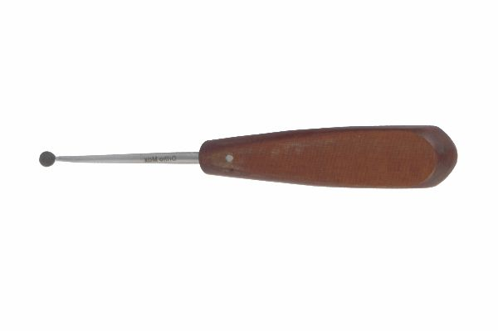
Function
The narrow working blade of the Ward elevator is driven subperiosteally using gentle finger pressure combined with a prying action. The fine blade tip enters tight spaces such as the infraorbital foramen rim, vertebral nerve foramina and interdental spaces where wider elevators cannot access without injuring adjacent neural or vascular structures. The lightweight handle provides sensitive tactile feedback during fine elevation work.
Advantages
Fine Blade for Foramen-Adjacent Elevation: The narrow Ward blade accesses the periosteum immediately adjacent to nerve and vessel foramina in the skull, mandible and vertebrae without contacting the neurovascular bundle at the foramen rim — critical for preventing iatrogenic nerve damage during dental and spinal procedures.
Lightweight Tactile Sensitivity: The slender, lightweight instrument construction maximises force transmission sensitivity to the surgeon's fingers, allowing immediate detection of periosteal plane entry and the change in resistance as the blade approaches nerve foramina and thin cortical regions.
FAQ
Q: What procedures use the Ward periosteal elevator specifically?
A: The Ward elevator is used in tooth extraction and mucoperiosteal flap elevation in veterinary dental surgery, and in vertebral foraminotomy and facet joint periosteal stripping during spinal decompression where the fine blade prevents neurovascular injury adjacent to foramina.
Q: How does the Ward elevator compare to the Howarth elevator?
A: Both are fine, lightweight periosteal elevators. The Ward elevator has a particularly narrow blade suited for foramen-adjacent and interdental elevation; the Howarth has slightly wider blades on its two ends and is more versatile across a range of spinal and orthopaedic elevation tasks.

